Networking Basics Report

OSI Model Layers & Functions
The OSI (Open Systems Interconnection) model is a conceptual framework used to understand how different networking protocols interact and communicate over a network. It consists of seven layers, each with a specific function.

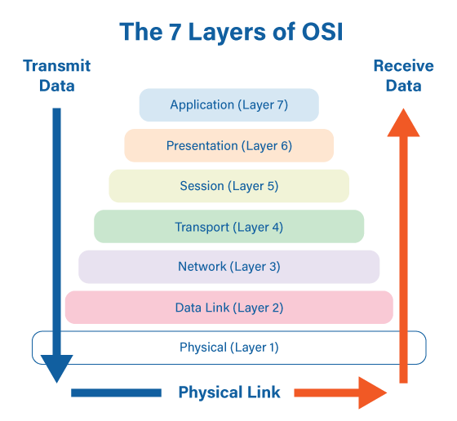

1. Physical Layer
This layer is responsible for the physical transmission of data through cables, switches, and hardware devices. It converts digital bits into electrical, optical, or radio signals.

2. Data Link Layer
The Data Link layer ensures reliable data transfer between devices on the same network. It detects and corrects errors that occur at the physical layer. It also handles MAC addressing.

3. Network Layer
This layer is responsible for logical addressing and routing. It determines the best path for data to travel across different networks. The Internet Protocol (IP) works at this layer.

4. Transport Layer
The Transport layer provides reliable data transfer between devices. It ensures complete data delivery using protocols like TCP (Transmission Control Protocol) and UDP (User Datagram Protocol).

5. Session Layer
This layer establishes, manages, and terminates communication sessions between applications.

6. Presentation Layer
The Presentation layer translates data between the application layer and the network format. It also handles encryption, compression, and data formatting.

7. Application Layer
This is the top layer where user applications interact with the network. Examples include web browsers, email clients, and file transfer programs.

TCP/IP Protocol Suite
TCP/IP (Transmission Control Protocol / Internet Protocol) is the fundamental communication protocol used for the internet and most modern networks. It consists of four layers:
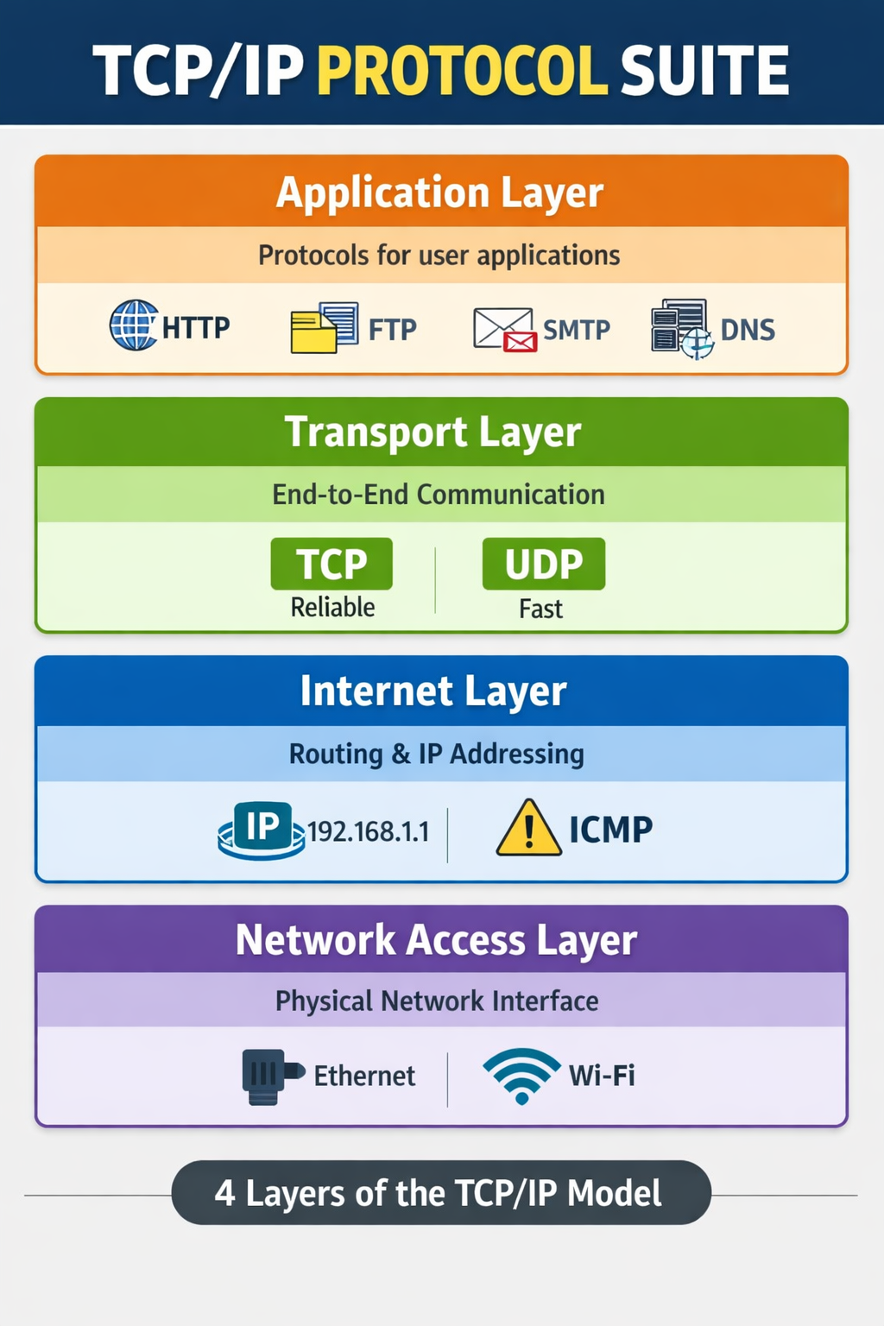

1. Network Interface Layer
This layer handles communication between the network and hardware. It includes Ethernet, Wi‑Fi, and other physical networking technologies.

2. Internet Layer
Responsible for logical addressing and routing of packets across networks using IP.

3. Transport Layer
Provides end‑to‑end communication services for applications using TCP or UDP.

4. Application Layer
This layer includes protocols used by applications such as HTTP, FTP, SMTP, DNS, and others.

DNS and HTTP/HTTPS
DNS (Domain Name System) translates human‑readable domain names into IP addresses. For example, when a user enters google.com in a browser, DNS converts it to an IP address so the computer can locate the server.

HTTP (Hypertext Transfer Protocol) is the protocol used for transferring web pages on the internet. It allows communication between web browsers and web servers.

HTTPS (Hypertext Transfer Protocol Secure) is the secure version of HTTP. It uses SSL/TLS encryption to protect the data being transmitted, ensuring confidentiality and integrity.

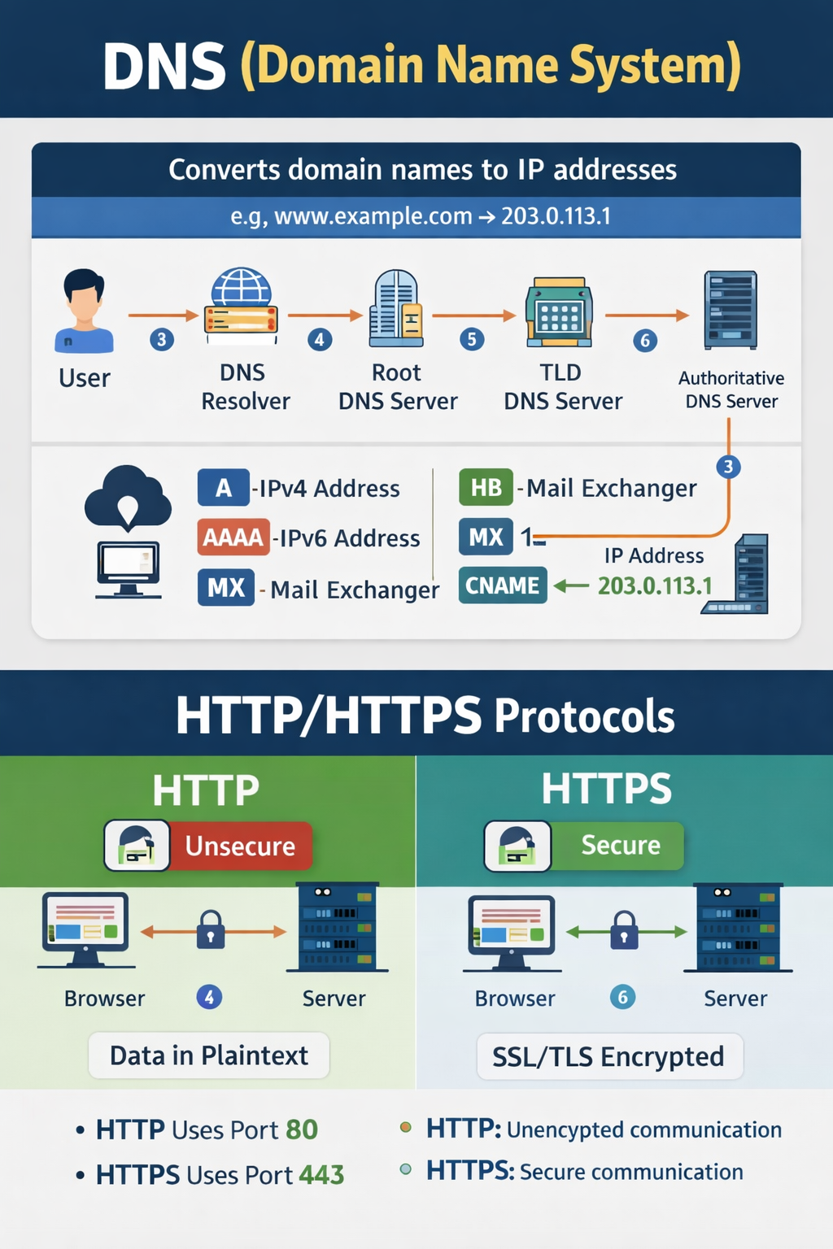

DNS Process:
1. User enters a domain name.
2. DNS query is sent to a DNS resolver.
3. Resolver contacts root, TLD, and authoritative DNS servers.
4. IP address is returned to the browser.
5. Browser connects to the web server using HTTP/HTTPS.

IP Addressing, Subnetting, and NAT
IP Addressing:
An IP address is a unique identifier assigned to each device connected to a network. There are two main types:

IPv4 – 32‑bit address format (example: 192.168.1.1)
IPv6 – 128‑bit address format designed to replace IPv4.

Subnetting:
Subnetting is the process of dividing a large network into smaller subnetworks. It improves network performance, security, and management.

Example:
Network: 192.168.1.0/24
Subnet: 192.168.1.0 – 192.168.1.255

NAT (Network Address Translation):
NAT allows multiple devices on a private network to share a single public IP address. It is commonly used in routers to conserve IP addresses and enhance security.

